**Thermo Assist Tool**

**Prepared by**

Varshesh Patel (15IT107)

Naqeebali Shamsi (15IT130)

Sarthak Thakkar (15IT144)

**Under the supervision of**

Dr. Amit Thakkar

A Report Submitted to

Charotar University of Science and Technology

for Partial Fulfillment of the Requirements for the

Degree of Bachelor of Technology

in Information Technology

IT322 Software Group Project-IV (6th sem)

**Submitted at**



**DEPARTMENT OF INFORMATION TECHNOLOGY**

**Chandubhai S. Patel Institute of Technology**

**At: Changa, Dist: Anand – 388421**

**May 2018**



**CERTIFICATE**

This is to certify that the report entitled “**Thermo Assist Tool**” is a bonafied work carried out by**. Mr. Varshesh Patel (15IT107), Mr. Naqeebali Shamsi (15IT130)** and **Sarthak Thakkar(15IT144)** under the guidance and supervision of **Dr. Amit Thakkar** for the subject of **6th** Semester of Bachelor of Technology in **Information Technology** at Faculty of Technology & Engineering – CHARUSAT, Gujarat.

To the best of my knowledge and belief, this work embodies the work of candidate **himself**, has duly been completed, and partially fulfils the requirement of the ordinance relating to the B.Tech. Degree of the University and is up to the standard in respect of content, presentation and language for being referred to the examiner.

|  |
| --- |
| Under supervision of,  Dr. Amit Thakkar  Assistant Professor  Dept. of Information Technology  CSPIT, Changa, Gujarat. |
| Prof. Parth Shah  Head & Associate Professor  Department of Information Technology  CSPIT, Changa, Gujarat. |

**Chandubhai S Patel Institute of Technology**

At: Changa, Ta. Petlad, Dist. Anand, PIN: 388 421. Gujarat

**Acknowledgement**

We get a rare opportunity to create this app. We are sincerely thankful to **Dr. Amit Thakkar**. We are also thankful to CHARUSAT UNIVERSITY for giving valuable suggestions.

VARSHESH PATEL (15IT107)

NAQEEBALI SHAMSI (15IT130)

SARTHAK THAKKAR (15IT144)

**ABSTRACT**

Here we have created a thermo assist tool to improve user experience and Energy Saving by efficient temperature manipulation according to user comfort. This tool is composed in android and Python language platforms with hardware platforms of Thermal sensors, humidity sensors, Raspberry pi3 and ardiuno-uno. The temperature manipulation is done by using Support Vector Classification (SVC) model for machine learning based effective temperature value and realtime user interface by firebase supported android application.

**TABLE OF CONTENTS**

**CHAPTER 1. INTRODUCTION………………………………………………………………6**

* 1. Project Summary………………….………………………………………….....…….6
  2. Scope………………………………………………………………………….………6
  3. Objective……………………………………………………………………….....…..6

**CHAPTER 2. SYSTEM REQUIREMENTS AND STUDY………………………………….7**

2.1 Software Requirement………...…………………………………………………....….7

2.2 Hardware Requirement………………………………………………………………...7

**CHAPTER 3. SYSTEM DESIGN…………………………………………………..…………..8**

3.1 Project Flow…………………………………………………………………..……......8

**CHAPTER 4. IMPLEMENTATION PLANNING……………………..………………….9-10**

4.1 Implementation Environment…..………………………………………………………9

4.2 Module Specification…………………………………………………………………..9

4.3 Coding Standards……………….………………………………………………………9

4.4 Snapshots Of Project………………………………………………………………..9-10

**CHAPTER 5. LIMITATIONS AND ENHANCEMENT…………………………………….11**

5.1 Limitations And Future Enhancement……………………………………….………..11

**CHAPTER 6. CONCLUSION……………………………………………………..………........12**

**CHAPTER 7. REFERENCE……………………………………………………….…………..13**

**Chapter 1. INTRODUCTION**

* 1. **Project Summary:**
* This project is based on automation in manipulating temperature for energy saving based on predictive temperature mechanism
  1. **Scope :**
* This tool learns user experience from feedback through android app for adjusting comfortable temperature in room.
* It is useful for maintaining automated temperature in all closed premises based on user experience, number of people in the room and temperature outside the premise.
  1. **Objective:**
* One of the main objective of our project is to learn development of Fullstack tool.
* Build a tool to increase User Comfort.
* Build a tool to fo efficient energy Saving.
* Introduce a new automation approach in temperature manipulation

**CHAPTER 2. SOFTWARE AND HARDWARE REQUIREMENT**

**2.1 Software Requirements:**

* Android SDK (SDK 19)
* Java (JDK 1.8.0_101)
* Android studio (3.1.0)
* Python (2.7)
* Django Server v2
* Firebase
* Scikit learn
* Pandas

**2.2 Hardware Requirements:**

* **Developer’s Level:**
* We need atleast 2GB RAM and 2GB Hard-Disk space.
* Although we use 8GB RAM for smoother work environment.
* **User’s Level:**
* Min. Android OS : 4.4.x (Kitkat).
* 5MB of free Space.

**CHAPTER 3. SYSTEM DESIGN**

**3.1 Project Flow**

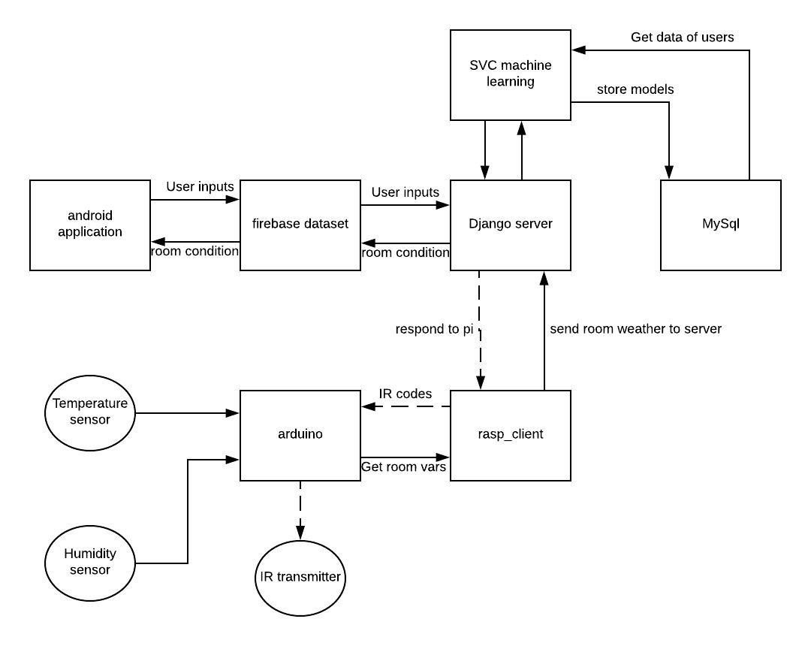

**Fig. 3.1 User Request Processing**

**CHAPTER 4. IMPLEMENTATION PLANNING**

**4.1 Implementation Environment**

* Android Studio
* Python Django Framework
* Ardiuno

**4.2 Module Specification**

* CPU Information Module
* Battery Information Module
* Device Status Module

**4.3 Coding Standards**

**MainActivity.java**

**activity_main.xml**

**rasp_client.py**

**sketchone_client.ino**

**Django_server.py**

**4.4 Snapshots Of Project:**

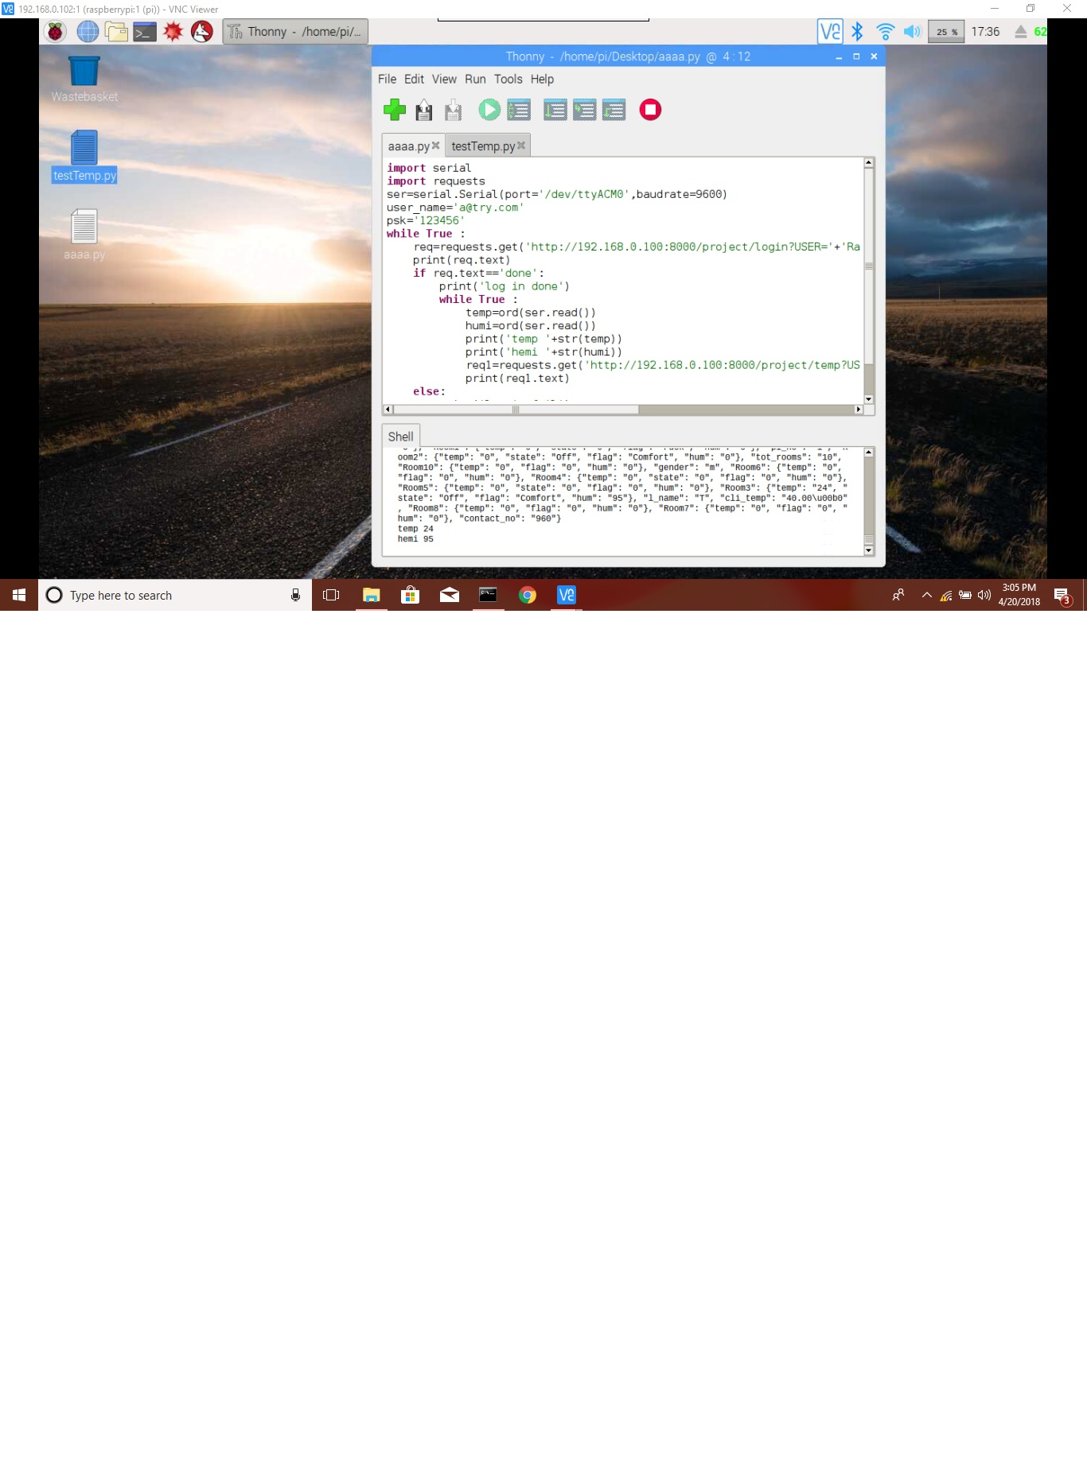

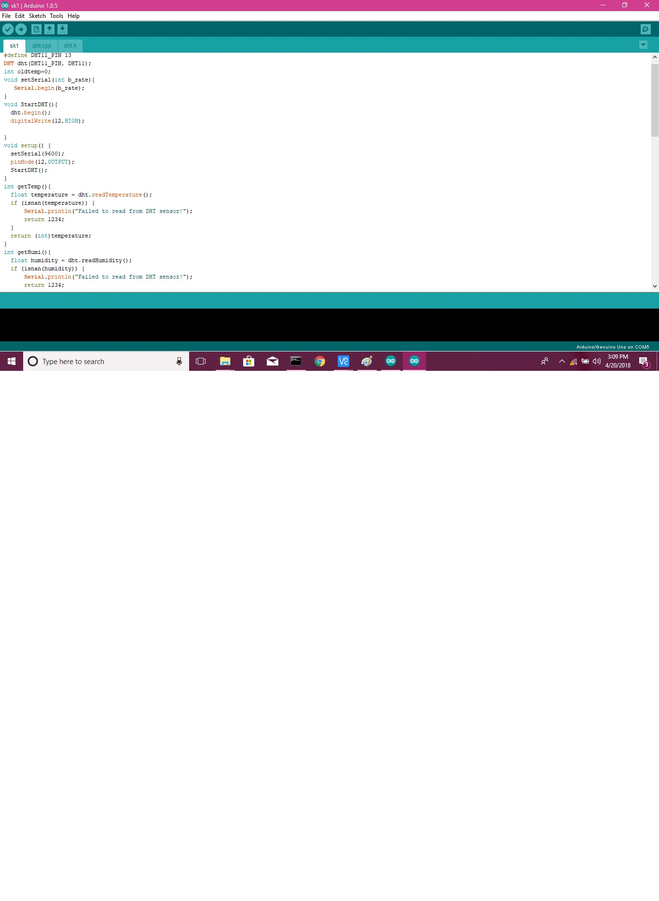

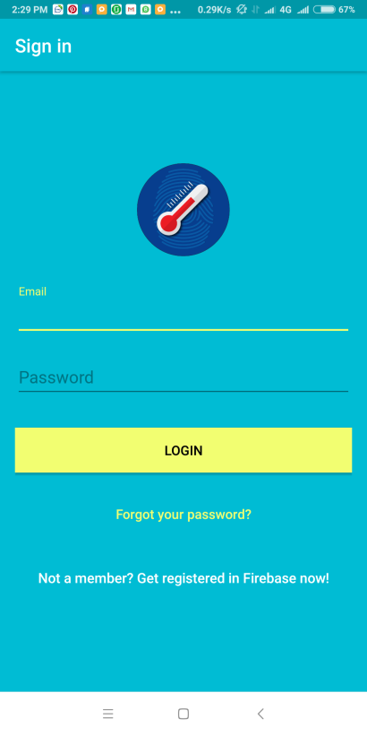 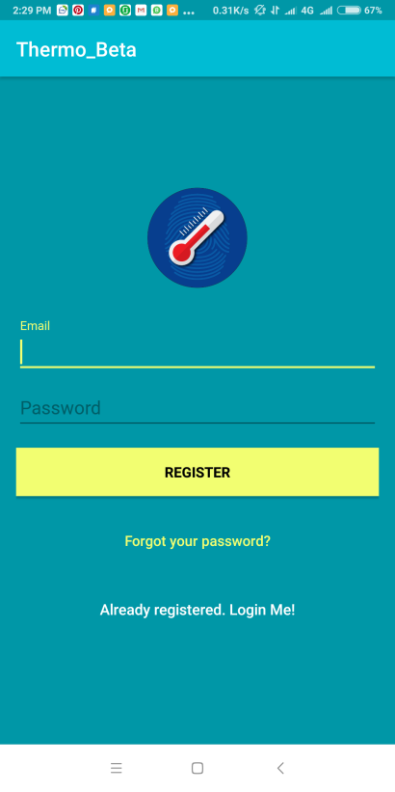**`**

**Fig. 4.1 Sign in Activity Fig 4.2 sign out Activity**

**Battery Monitor Activity:**

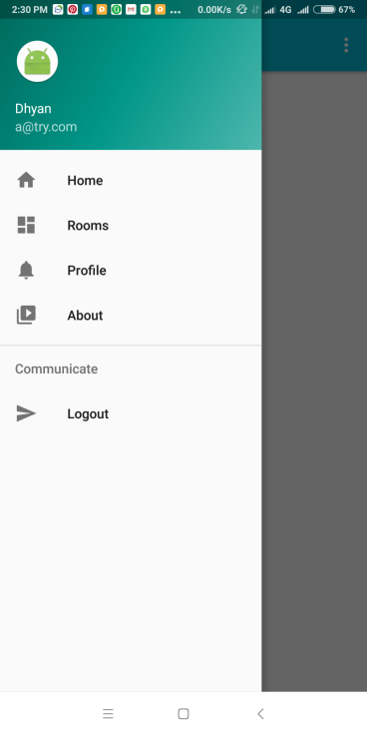 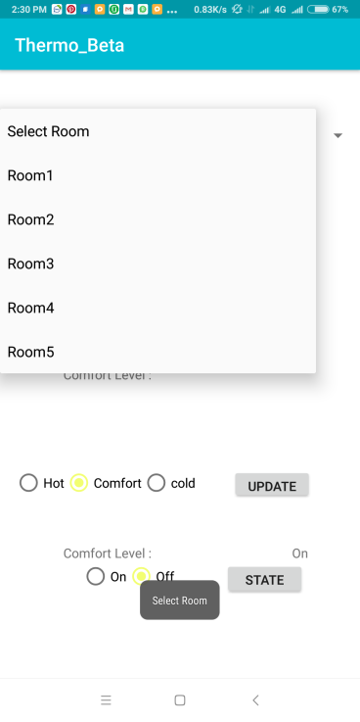

**Fig 4.3 Navigation Drawer Module Fig 4.4 room monitoring Module**

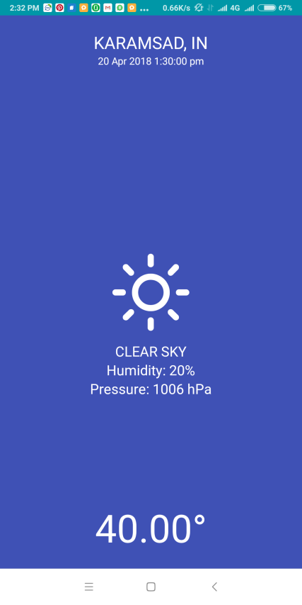

**Fig 4.5 Current Temprature Activity Fig 4.6 About Activity**

**CHAPTER 5. LIMITATIONS AND FUTURE ENHANCEMENTS**

**Limitations**

* Commmunication Between server and client is critical.
* Sensor Accuracy is limited to temprature.
* Different configuration is required for each house access compatibility.
* Limited to only android users.
* Analytics and admin panel not yet developed.

**Future Enhancements**

* Improve Temperature sensors to sense heat map of room and number of people.
* Build user friendly Admin Pannel.
* Give better

**CHAPTER 6: CONCLUSION**

This project reduces energy consumption and simultaneously provides users control and comfort powered by machine learning.

It also provides ease of access to the users so that they may control, manage and provide feedback to the system so that it may function seamlessly.

**REFRENCES:**

1. Android developers (https://developer.android.com/guide/index.html)
2. GitHub Forums (https://www.github.com/python/pyrebase/forums)
3. Udacity (https://www.udacity.com/courses/android)
4. Youtube (https://www.youtube.com/android)